REAL ESTATE DATABASE

List of tables

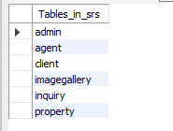

Admin Table:

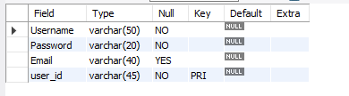

Client Table:

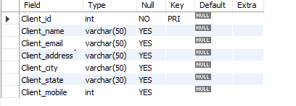

Agent Table:

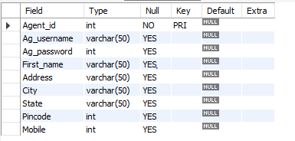

Image Gallery Table:

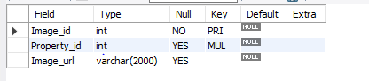

Inquiry Table:

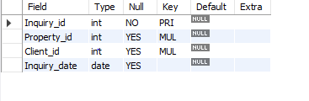

Property Table:

